

Badminton Gloucestershire County Annual General Meeting

Tuesday 11th June 2019 7.30pm

Hucclecote Community Centre, Hucclecote Rd, Gloucester GL3 3RT

AGENDA

1. County Directors Welcome
2. Attendance & Apologies
3. Minutes of 2018 Meeting
4. Matters Arising
5. Presentation of Reports

* Coaching
* Tournament Secretary
* Junior County
* Seniors 1st & 2nd Team
* Masters
* Community
* Performance Centre

1. Report and Approval of Accounts & County Affiliation Fee
2. County Director Report
3. Election Of Officers

* County Director – Andy Woolway
* Assistant Director – James Siddle
* Honorary Secretary – Becky Pantaney / Emily Witham
* Honorary Treasurer - Becky Pantaney / Emily Witham
* Head Coach – Becky Pantaney
* Schools and Community – Mike Griffiths
* Schools and Community Assistant – Sol Griffiths
* Masters Co coordinator – Penny Trebilcock
* Registration Secretary - Becky Pantaney / Emily Witham
* Tournament Secretary – Sam Evans
* Junior Fixtures Secretary – Francis Ackroyd
* League Representative – Ian Woolway
* Senior County Selection – Becky Pantaney, James Read, Linda Pearcy, Chris Hotchen

1. AOB

Apologies to andywoolway88@gmail.com

***Directors Report – Andy Woolway***

This has been my first year in the Directors role after assisting Graham Siddle for a year. I want to start off by saying that the teams across every age group have been a credit to the county this year from the ICT team finishing 22nd (up 8 places from the previous year) all the way up to the O60’s who finished 2nd in their division. Special mention needs to go to the O45’s who have had much success this year finishing runners up in the County Challenge and were crowned Over 45’s National County Champions.

Work continues to happen on the community side of BG to ensure we have more players coming through the system and I’d personally like to thank Mike Griffiths, Sol Griffiths and Becky Pantaney for the hard work they have been doing with the schools initiative.

We continue to have a ‘work force’ issue where we have a small group of coaches who are spread thinly. This has inevitably made it difficult to do everything that we would like to do but the provision for badminton is out there. The performance centre has opened a new junior club but the interest has been low. This has been the same for some community events, which have unfortunately been cancelled due to low interest. This is a battle we continue to fight and welcome any help with.

The account remain healthy but we are beginning to spend money where we can. £5000 is ring-fenced for the school initiative to continue and to target more primary schools. Affiliations continue to be an essential stream of money to ensure we are able to fund initiatives throughout the county. Next season the county will be running some national circuit tournaments so hopefully this will provide us with more revenue so we can try to do more for the county. Any help with these would be much appreciated and we do need volunteers to help from organising to shuttle monitors on the day.

Becky Pantaney is standing down from all roles within the county, which is a real shame, and I would like to thank her for her hard work within the county – especially this year as I believe the county could have been in real trouble if she had not taken on as many roles as she did. I hope that she will remain an integral part of the county first team and a role model to the younger players. This does leave a lot of gaps within the committee and we are always looking for volunteers so please do speak to me if you are interested in helping.

***Coaching report – Becky Pantaney***

This season has seen some stability in the number of coaches involved in the core training that takes place within the County, although the demand on these is increasing with the want for more schools and community sessions. We have seen a Level 1 coaching course take place and a few of our junior players are now qualified and starting to become active within clubs and activities taking place. I hope that in the future these can train towards a Level 2 and become a more influential part of the coaching structure.

Pc and County coaches continue to be present at shared training sessions that have also taken place this season with good success. We are aware of the younger players that are out playing at junior clubs and will be keeping in contact with these to assess progression over the coming months. Coaches have been out to visit clubs and see all their players in their home environment for any that could not make the shared days.

On top of the shared training sessions, coaches have been at a number of the Community competitive play sessions. These involve the half court singles tournaments, non-county players tournaments etc.

This year all Community and Club coaches were invited to come into a PC training session to see what goes on, chat to the coaches and ask any questions they may have. This offer was taken up by a few coaches and the conversations and information shared I think proved very valuable to both sides. Will look to continue this next season.

Lastly, this year saw a group of Glos Coaches attend the Volunteer Conference that took place during the All England.

***Under 18 county Report – Sol Griffiths***

The under 18’s have enjoyed a very positive season. Last season we made the decision to enter the team in to both shires and southwest leagues. This proved challenging to field teams, especially in the southwest matches as they require 6 boys and 6 girls. We managed to get a team out for matches except 1. The results have been positive winning shires league matches against, gwent, Avon 2 and Herefordshire . Other fixtures with Buckinghamshire and Berkshire provided very strong opposition allowing the players to have a positive learning experience. The players have showed a real hard working attitude every week at training. This attitude was reflected in an excellent performance at ICT finishing 22nd out of 32 teams, this was a jump up of 8 places. The 17-20 team represented Gloucestershire at ICC this year also seeing a rise in their final position from 16 up to 14. The players conducted themselves excellently throughout the tournaments and we should all be proud of their achievements. The players will hopefully now kick on in to senior badminton, as many of our juniors could be assets to senior county teams for many seasons to come with Reece, Sian, Amy and Vivi playing this season.

Hopefully we can keep building next season. We have worked hard to create a positive training environment on Tuesday evenings, and will continue to try to grow a strong squad, helping our top juniors to improve their badminton.

I would like to thank all those who have supported Dom and I this season, it has been very much appreciated. A special mention to Dave/Sam for their excellent job as team managers and to Frances for sorting out the fixtures

***County 1st team match report 2018/19 – Chris Hotchen***

Sat 10 November 2018

On the first weekend, Gloucestershire played Worcestershire and Cornwall. Gloucestershire got off to a much better start against Worcestershire than when they played the previous year earning a 3-2 lead after the singles. Special mention to Henry Jones who won his singles in three sets on his first team debut.

However, despite a very close three set win by Bex/Linda in the ladies doubles (28-26 in the third) and spirited efforts in the mixed by Ian/Kerry and Sol/Linda (both going to three sets), Worcestershire fought back to eventually win the tie 6-5.

The afternoon fixture was against Cornwall, who were newly promoted into the division this year. Gloucestershire again took an early 3-2 lead after the singles. Abbie/Kerry were on the wrong side of another very close three set encounter, but a strong display by Kerry/Ian in the mixed helped Gloucestershire beat the young Cornish side 7-4.

Sat 26 Jan 2019

Gloucestershire were missing a number of nominated players on the second weekend. However, with particular thanks to Mandy, Joe H, and Justin Andrews for agreeing to play, we were still able to put out competitive teams against two very strong Avon sides. Unfortunately, we went down fighting, losing 9-2 and 7-4 against Avon 2’s and 3’s respectively. However, these score lines do not reflect how close the games really were – 9 of the matches went to three sets, but Gloucestershire were only being able to convert 2 of those three-set matches to a win (well done Bex in her singles, and Ian/Sol in their men’s doubles).

Sat 23rd – Sun 24th March 2019

The final weekend saw some younger players have a chance to show what they can do at first team level; and there were some excellent performances.

Our first match was against Devon. We lost the first two men’s singles matches, but fought back to be 3-2 up after all singles had been played after some excellent wins from Henry and Bex. A particular mention to Vivi who had a fantastic win in her singles on first team debut against a difficult opponent. Despite a good win by Sol/Jamie in the men’s doubles and another spirited display by Ian/Linda in their mixed doubles, Devon eventually won the match 6-5 in a closely fought contest.

Our penultimate match was against Wiltshire, who we have had many tough matches against in the past. This was no different. Gloucestershire took an early 4-1 lead after the singles, with Sol claiming his first win over (an albeit poorly) Simon Woodhouse; and Vivi claiming her second win of the day. Mandy/Linda had a tough three set battle and Gloucestershire struggled in the men’s doubles, but wins from Bex/Linda and Ian/Kerry meant that we finished as 6-5 winners.

The final match of the season was against Devon 2’s. Gloucestershire put in a fantastic team performance finishing as comfortable 9-2 winners. A special mention to Kerry who rolled back the years to win her singles match!

Concluding Remarks

The excellent performances on the final weekend meant that Gloucestershire first team finished 5th in Divison 2 (South West).

I would like to thank everyone who represented the first team this year, which includes: Bex, Henry, Kerry, Ian W, Sol, Jamie, Linda, Andy W, Vivi, Joe H, Mandy, Justin, Shy, and Abbie.

Last and by no means least, I would like to thank the selection committee for their help in the unenviable task of trying to select fair and balanced teams - many thanks to Bex, James and Linda for their help. This season, the selection committee aimed to give younger players more experience at first team county level. I think we achieved this by giving Henry and Vivi first team debuts. Going forward, I believe we need to continue to give juniors the opportunity to play at senior county level so that we can build a strong team for the future and for many years to come.

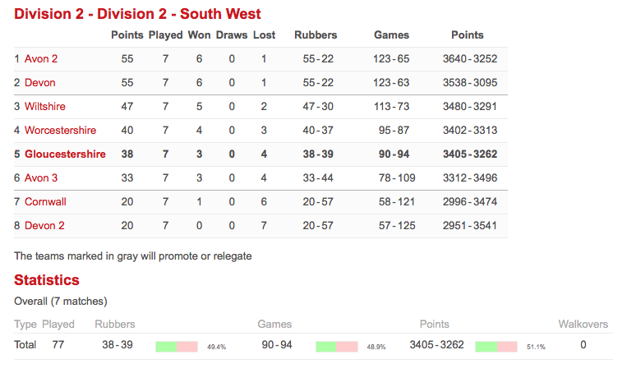

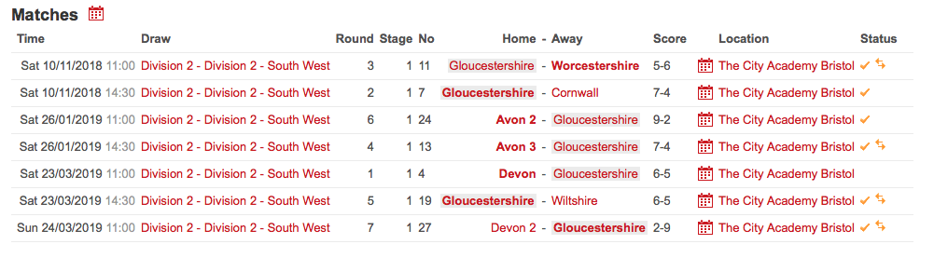

**Gloucestershire 2nd Team Report –18/19 – Captains: James Read/Jon Horsfield**

Summary: The team finished 5th (out of 8) and will remain in South West Division 3 for next season.

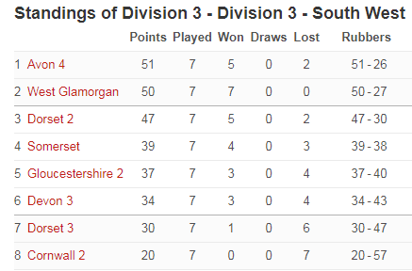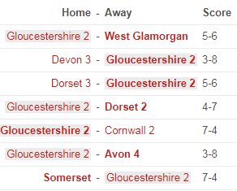

**The 2nd team this year was represented by:**

**Men**: Jamie Pearcy, Dom Jones, Joe Honeybone, Jon Horsefield, James Read, Adam Watts, John-Joseph Pye, Andrew Woolway, Reece Watts

**Ladies**: Emily Prankard, Isla Townley, Mandy Joiner, Sian Evans, Ceri Evans, Vivi Jennings-Trace, Anna-Marie Abdon, Amy Oakley, Sharmin Price

**Season Report**

18/19 was another great season of badminton with 18 different players representing the 2nd team over 3 tough weekends. As we’ve seen over the last few years, this division has been tough to win, and easy to lose – the margins are tight and any team can be a threat on the day. Perhaps the notable exception this year was Cornwall 2 who finished 10 points clear at the bottom of the table and didn’t win a single match. At the other end West Glamorgan won 7 out of 7, much improved on previous seasons – although still only managing a 2nd place behind Avon 4, who as we’ve seen before can draw from the strength across it’s squad to bolster teams where required on the run to the finish line.

**Weekend 1:** We didn’t know it, but a narrow 5-6 defeat to West Glamorgan was actually one of the results of the season. The presence of Jamie Pearcy was a notable boost, as he took a valuable singles against Victor Pang, and also combined with Jon Horsefield to win his doubles. Joe Honeybone started his singles season well winning in 2 sets, and Mandy Joiner and Sian Evans won their doubles, along with James Read and Isla Townley in the mixed.

This was followed up by a strong 8-3 win against Devon 3rds, with Jamie, Joe and Vivi all winning their singles, James & Adam, Jon & Joe making a clean sweep in the men’s doubles, and Mandy & Sian once again proving to be an effective doubles pair winning in 3 sets. A final 2 points were picked up in the mixed, with James & Isla winning in 2 sets, and Jamie & Mandy coming back from a set down to win in 3!

**Weekend 2:** A narrow 6-5 win against Dorset 3 gave us a positive start to the weekend, but was tough in the making, as we went 4-1 down in the singles with Jon Horsfield picking up the only point. Both Sian and Ceri Evans battled to the end but each lost in 3 sets to tough opposition – great games to watch and promising to see youngsters coming through and showing the ability and determination to compete in singles at that level (which they would later prove!) James & Adam came through the doubles in 3 sets after a sleepy start, with Jon and John-Jo winning theirs comfortably in 2. Sian teamed up with super sub Anna-Marie to win their doubles, with Emily & Ceri narrowly missing out in a ferocious 3 setter. With both mixed needed to win the match, it was a tense end as James and Anna-Marie won in 2, and Adam and Emily finished the morning taking victory in 3 sets – phew!

The afternoon match against Dorset 2 was naturally going to be a tougher affair, with the eventual score going 7-4 to Dorset. Things started well as we exited the singles 3-2 up, with Jon, Sian and Ceri all taking deserved and valuable wins. Thereafter however things got hard, with Dorset taking a clean sweep across the men’s doubles, ladies doubles and winning the first mixed opener. James & Anna-Marie clinched the final mixed, leaving us with a respectable 10 points for the weekend.

**Weekend 3:** The team started the final weekend in fine fashion against bottom of the table Cornwall 2nds. Getting off to a rare 3-0 start by taking a clean sweep in the men’s singles, courtesy of Dom Jones who had up to this point faced unusually stiff opponents (and not been rewarded for his efforts!), Joe Honeybone, and Jon Horsfield who had to work hard for his 22-20 3rd set win. Amy Oakley made her senior county debut putting up good fights in singles against a higher graded opponent. The ship was steadied as the men’s and women’s doubles were split with the wins coming from Andy & Joe, and Shy & Isla. The team continued their good form into the mixed winning both courtesy of Andy & Shy, Adam & Isla, easing to a 7-4 victory.

The afternoon match against Avon 4th team provided a tougher prospect, with Avon having drafted in some strong players. The singles was an uphill battle, with the team eventually going 5-0 down – a tough debut for Reece Watts who fought hard against a strong Bath Uni player. Andrew Woolway and Joe Honeybone got the team up and running with a hard fought 3 set win in the doubles, and the team continued their run of strong form in the mixed recording 3 set wins in both. Particular credit must go to Dom Jones and Isla Townley who battled off an experienced B grade and former England Junior lady! The match ended 8-3 to Avon 4th team who would subsequently win the league and gain promotion.

Going in to the Sunday against Somerset, the team had its fair share of aches and pains (and one or two sore heads…?). Joe Honeybone brushed off the whiskey fireballs to record a 21-9 21-9 win. Jon Horsfield had another hum-dinger against the Somerset number 3 and came out on top after 3 tough ends. The ladies faced a tough task, going up against arguably the best ladies in the division, with an easier task for the men who recorded comfortable wins. The mixed went to Somerset with the eventual score 7-4 to Somerset.

The team finished 5th in the division – one place higher and 4 points better off than last year – a steady improvement that all involved can be proud of.

Thanks to Jon Horsfield who took over the captain’s armband for the final weekend as James was awaiting the arrival of his new baby!

***MASTERS ANNUAL REPORT – SEASON 2018/2019 – Penny Trebilcock***

As always, I am starting with the usual plea for more Masters players to come forward. We

finally had two teams this season, the 45s and a new 60s. Despite asking around wherever I

play or when teams visit my own club, plus a note on the website, still there are not enough

players, and indeed the two teams entered had to look around for players on a couple of

occasions. Surely for such a large County we could do better ? Speak to your peers, find

someone who would be prepared to captain your team and contact the County accordingly.

There are competitions in all age groups from Over 40s to Over 70s. Teams consist of 4

women and 4 men, other than the Over 65s and 70s, where teams consist of 3 women and 3

men. There is a possibility of an Over 75s league for the new season, so plenty for everyone.

League Teams/Challenge Team

We entered two teams into the main leagues – an Over 45s, and an Over 60s, plus a Challenge Team for the Over 45s.

The Over 45s did well again, and the Captain, Linda Pearcy, reports :

“Once again we have had a very successful season winning all our division games. I would

particularly like to thank Richard Barnett and Alistair Pearcy for stepping in and playing

very well getting important points for us and helping us out through our injury absences.

We had a very successful County Challenge weekend in which we ended up being

runners-up. This was a shame as we would have won it but for the fact that one of our key

players got injured during one of the games in the early stages of the completion and had to

pull out. There were some great performances from the team especially Mike Kennedy and

Zuli Tejrar. For the second year on the trot now we have been crowned 045's National

Champions. I would like to thank all the team Mike Haywood, Zuli Tejrar, Mike Kennedy,

Dave Evans and Phil Richardson, Mandy Joiner, Jo Hammond, Rhonwen James and Rachel

McGill for a fantastic effort and great season!”

The team went to the Finals weekend, and got through to the final (not without some injury

scares along the way, and finally played Surrey (who had defeated Nottingham 11-1 in their

previous match.) The match was nip and tuck all the way, but eventually Gloucestershire

Over 45s did what they had to do and won the match 7-5, to be crowned Over 45s National

County Champions. All in all, a very good season. There is a full match report available on

the website if you want to read the whole story, not just these highlights.

The Over 60s had a good first season, and although they got off to a bad start, they ended as

runners-up. The Captain, John Sexton reports :

“ The season did not get off to a good start, first match was away to Worcester 1 who we found to have most pairs formed for a long time, unlike us who turned up on spec and formed pairs by asking who had played with someone before, a 10-2 defeat was not a good start, however we didn't feel we had been that badly outplayed. After that we had 3 wins against Warwickshire, Shropshire and Worcester 2. After Christmas we had the return fixture against Worcester 1 again we had a defeat 8-4 however the games were much closer and a possible 6-6 draw was very close. We finished with 3 wins. Overall we were runners up to Worcester 1. 12 players represented the County  6 men and 6 ladies we need more players.”

GENERAL

The 60s enjoyed the season and will field a team again next season, and are also entering a

County Challenge Team, so that is some progress. However they did find it hard to explain to players who were filling in that they would need to purchase a compete licence (although in an emergency players can play once without the necessity to upgrade). However, particularly for the ‘older’ players, the question was asked whether perhaps the County should pay for the upgrade because they pay this additional cost for just the few Masters games they play?

There were the usual moans about the home venue, and also the question of costs for

travelling to the Isle of Wight. Match fees are not paid for this away match, but the ferry

costs are high – again is there a case for the County to subsidise this fixture ? Always good to

end a report with some questions for the next season !

And finally – come on Gloucestershire Masters Players – more teams and players are needed.

In the words of that famous quote (slightly amended I know) – “Your County Needs You!

***BG Community Report***

Badminton Gloucestershire Community organise and run Junior Leagues for junior club players in the Key Stage 3 and Key Stage 4 age-groups. Following are the results for 2018–19.

|  |  |  |  |  |
| --- | --- | --- | --- | --- |
| TEAMS  KS3 | Points Total/  Position Round One | Points Total/  Position Round  Two | Final Points Total | Final Position |
| Balcarras 1 | 451  3rd | 363  1st | 814 | 1st |
| Balcarras 2 | 435  4th | 309  5th | 744 | 5th |
| Bournside 1 | 392  6th | 141  8th | 533 | 8th |
| Bournside 2 | 245  10th |  | 245 | 10th |
| Falcons | 379  7th | 243  7th | 622 | 7th |
| Kestrels | 460  1st | 333  3rd | 793 | 2nd |
| Marling | 452  2nd | 340  2nd | 792 | 3rd |
| Pittville 1 | 424  5th | 321  4th | 745 | 4th |
| Pittville 2 | 360  8th | 264  6th | 624 | 6th |
| Newent | 343  9th |  | 343 | 9th |

|  |  |  |  |  |
| --- | --- | --- | --- | --- |
| TEAMS  KS4 | Points Total/  Position Round One | Points Total/  Position Round  Two | Final Points Total | Final Position |
| Allsorts | 234  3rd | 235  3rd | 469 | 3rd |
| Balcarras 1 | 219  5th | 186  5th | 405 | 5th |
| Balcarras 2 | 282  1st | 293  1st | 575 | 1st |
| Falcons | 240  2nd | 246  2nd | 486 | 2nd |
| Pittville | 229  4th | 235  3rd | 464 | 4th |

Half Court Fun Tournaments

Half court tournaments were successfully organised at Christmas and Easter aimed at introducing young players from 8 to 16 years of age to badminton competition. Over 70 players participated overall.

KS2 Meet and Compete

In response to a growing number of junior school aged children participating in badminton several KS2 Meet and Compete Experiences were held providing basic skills practice and game play.

Secondary Schools Pilot Initiative

Eight secondary schools participated in the pilot initiative providing CPD and in lesson support for PE staff. Feedback from schools has been extremely positive and it is planned to offer the experience to schools again during 2019 -20.

Annual Charity Tournament

With over 70 entries £250 was raised for ‘Scoo-B-Doo’ which supports the care and treatment of premature and sick babies at Gloucestershire Royal Hospital.

Forthcoming Badminton Gloucestershire Community Events

|  |  |  |
| --- | --- | --- |
| Annual Charity Tournament | *Sat 29th June*  *11:00 - 6:00pm*  *Bournside Sports Centre* | *Tournament Structured in Key Stages:*  *KS2*  *KS3*  *KS4 and Sixth Form* |

For further details/entry forms contact [mikegriff54@hotmail.co.uk](mailto:mikegriff54@hotmail.co.uk)

***Performance Centre – Ian Woolway***

This year the PC has been a settled year in terms of membership levels with a number of players leaving for university and being replaced by new members at the start of their badminton journey. We continue to be able to accommodate more members and with the new “club” session 6-7pm hopefully this is the start of a new pathway within the PC that will drive both the number of juniors playing badminton and also the standard with the club specifically targeting a younger audience of 8-12 year olds.

The club is in the early stages now with 4/5 regular attendees. A bigger presence on social media and more engagement in schools will hopefully see this number grow.

Over the past year the introduction of a hitter into the late session has been positive and coaches attending tournaments has also been beneficial. The medal count from tournaments has increased this year, however the aim is to get more juniors contributing to the medal tally.

|  |  |  |
| --- | --- | --- |
|  | **2017/18** | **2018/19** |
| **Gold** | **20** | **25** |
| **Silver** | **24** | **15** |
| **Bronze** | **15** | **25** |
| **TOTAL** | **59** | **65** |

The tournaments have again been a very successful part of the PC contributing to both the finances of the PC and the opportunity it gives players to play on the national circuit without travelling too far. This year will see a split in tournaments between the PC and County to spread the benefits.

Financially the PC is stable and has started to eat into its reserves. Spending will follow a similar pattern this year with investment into areas such as more coaches in sessions and training for new coaches. We will continue to invest in beneficial projects and improvements however will not spend for the sake of it.

2019/20 will see more focussed training with additional coaches in sessions and a greater emphasis on smaller pockets of players training together. The club session is also a massive focus point bringing cheap, fun badminton to younger children getting them excited about the game and hopefully wanting to progress through the PC.

***Accounts – Becky Pantaney and Emily Witham***

